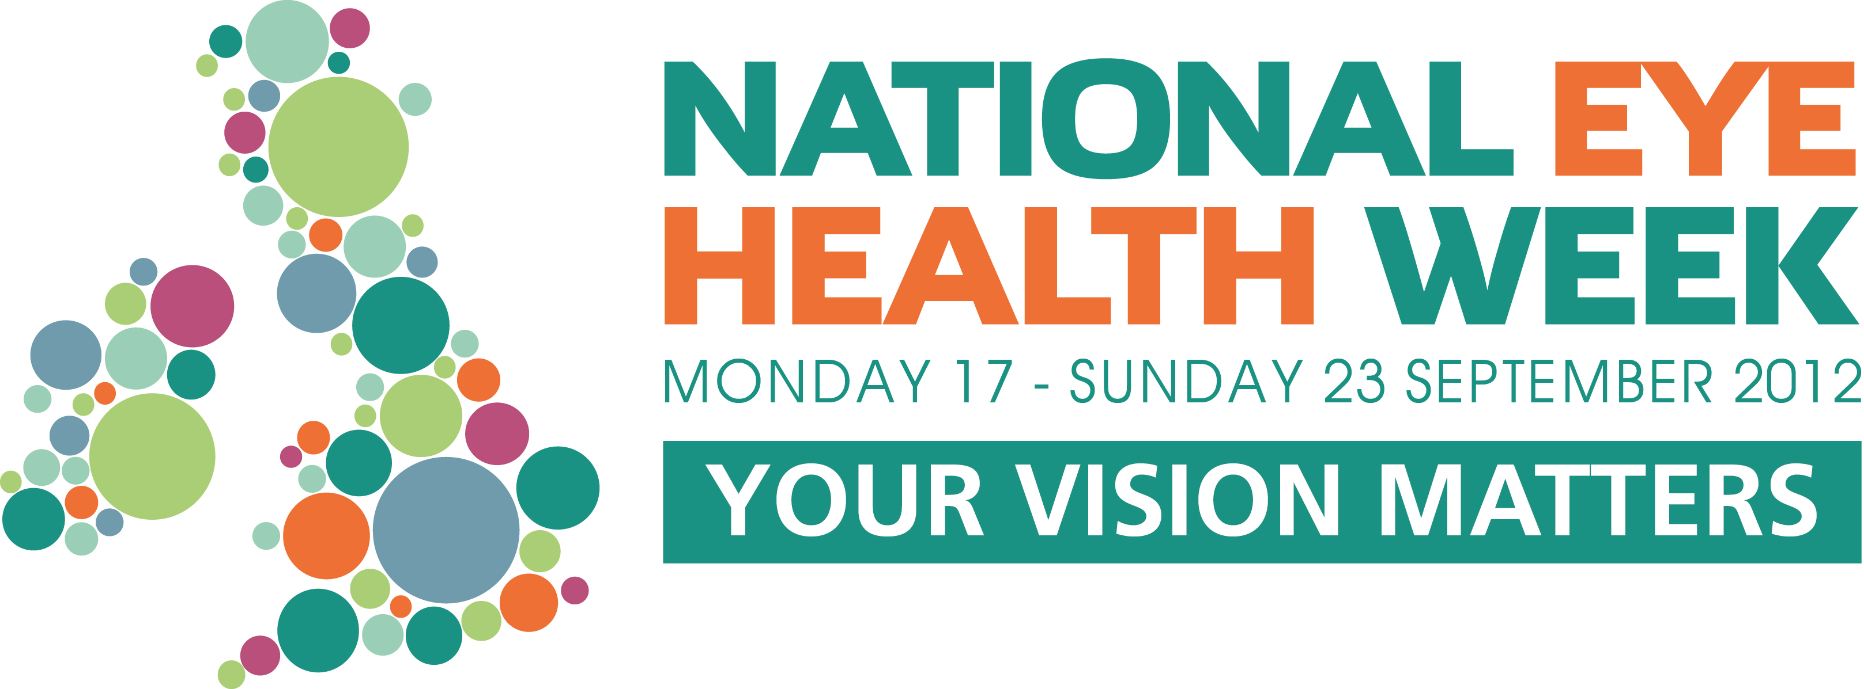
Feedback form

1. How did you mark National Eye Health Week (NEHW) 2012?
(Please tick all that apply)

Hosted an eye health awareness day o
Held an over 60s coffee morning o
Gave a talk at my local school o
Displayed posters leaflets in my office/practice/workplace o
Held a charity fundraising event o
Did the Carrots NightWalk o
Attended an eye health event o
Issued a press release o
Did an interview on local radio/television o
Ran a promotion o
Held a prize draw /competition o
Placed an advertisement in my local media o
I didn't mark National Eye Health Week o

Other? (Please specify)

2. How would you rate the success of your own National Eye Health Week activity and what ONE thing could have helped make your activity more successful?

A roaring success o
A success o
Not very successful o

The one thing could have helped make my activity more successful is...

3. Which of the following resources DID you, or WOULD you, find useful to help you celebrate National Eye Health Week?

 | Very Useful | Useful | Not Useful
Logo
Guide to Getting Involved
Posters
Leaflets (generic)
Leaflets (disease specific)
Fact sheets
Template press release (events)
Template press release (news)
Guide to securing media coverage
Kids activity sheets
Kids stickers
Photo library
Branded balloons
 | Very Useful | Useful | Not Useful
Branded appointment reminder cards
Events guide
Template advertorial
Template advertisement
Simulation specs
Template letter to your MP
Opportunity to register your event on www.visionmatters.org.uk

Other? (Please specify)

4. How did we do? What aspects of the 2012 National Eye Health Week campaign do you think worked well and what didn't?

 | Worked well | Didn’t work well | Don’t know
Guide to getting involved
Electronic resources
Resource starter-kits
Online event calendar
Responding to individual enquiries and requests
Gaining media coverage
Securing support from parliamentarians
Vision Matters website
@myvisionmatters twitter feed
Vision Matters facebook

Tell us about any other aspects of the campaign that you think either worked well or could be improved...

5. Did you read, see or hear any eye health stories during National Eye Health Week (17 -23 September)? (Please tick all that apply)

Yes, on national TV o
Yes, on national radio o
Yes, in a national newspaper or magazine o
Yes, online o
Yes, on local television o
Yes, on local radio o
Yes, in my local paper o
Yes, but I can't remember where o
No o

Other (Please specify)

6. Do you plan to support National Eye Health Week in 2013?

Yes o
No o
Undecided o

7. Do you think that September is a good time of year to hold National Eye Health Week?

Yes o
No o

If No, why not?

8. Do you have any ideas about how National Eye Health Week could be improved for 2013?

9. We’d also love to hear any other comments you may have about this year’s, or future National Eye Health Weeks…

10. Are you on our mailing list? If you’re not, but would like to be please tell us your name, organisation, email, phone and address. Please note we will only use this information to keep you informed about National Eye Health Week events, news and activities.

Please send your completed feedback form to:

National Eye Health Week 2012 Feedback
PO Box 804
Aylesbury
BUCKS
HP20 9DF

Alternatively you can email your responses to
rachel@visionmatters.org.uk

This feedback form is also available online @ http://www.surveymonkey.com/s/3KNQPSV

Please ensure all forms are returned to us no later than midnight on Wednesday 10 October 2012.

